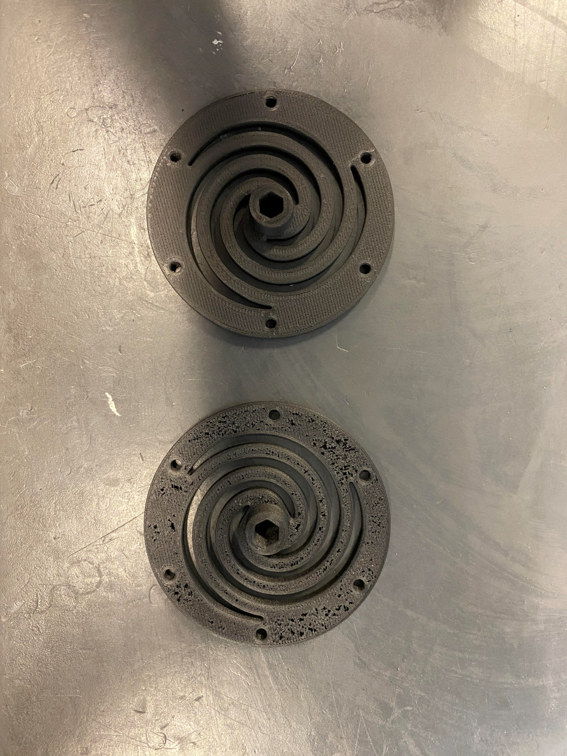

Top Surface

Mark Two

Onyx One

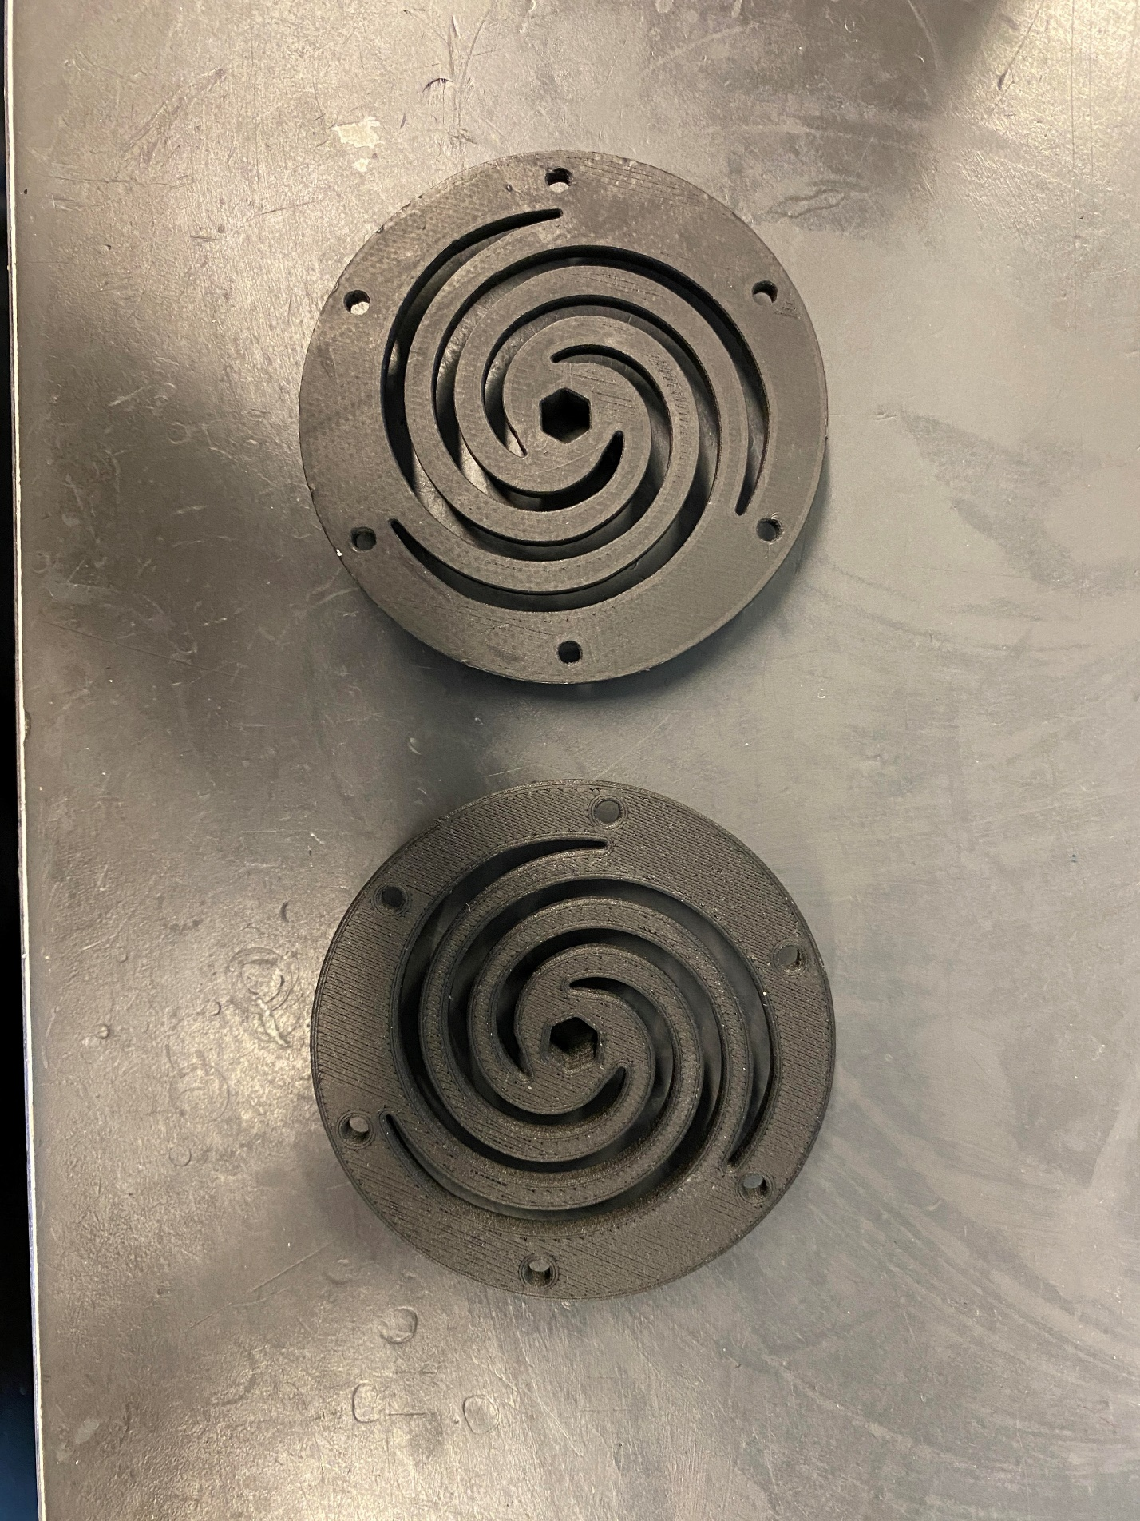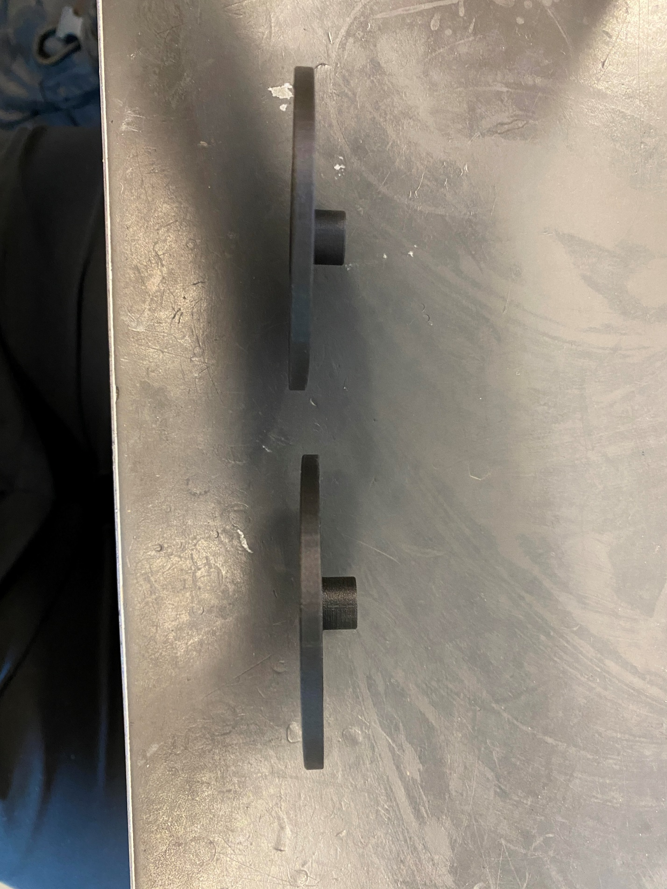

Bottom Surface

Onyx One

Mark Two

Side Walls

Mark Two

Onyx One